Software Design Description
Version 1.1
December 8, 2003

Web Accessible Alumni Database

Michael J. Reaves

Submitted in partial fulfillment
Of the requirements of
Masters Studio Project

Table of Contents

Table of Contents ii
Table of Figures iii
1.0. Introduction 1
1.1. Purpose 1
1.2. Scope 1
1.3. Glossary 1
1.4. References 2
1.5. Overview of document 2
2.0. Deployment diagram 4
3.0. Architecture design 4
3.1. Web System Architecture 4
Alumni Home Page 5
Survey 5
Entries 6
Search/E-mail an Alum 7
Alumni Database 9
4.0. Data structure design 11
4.1. Data field types and sizes. 11
5.0. Use case realizations 12
Use Case: Survey 12
Use Case: Add Entry 13
Use Case: Update Entry 14
Use Case: Search/E-mail Alum 14
6.0. Interface design 15
Figure 23 Return used instead of Submit 22
7.0. Help system design 23
8.0. Index 24

Table of Figures

Figure 1 Deployment Diagram 4
Figure 2 Architecture Design 5
Figure 3 System Sequence Diagram 12
Figure 4 Survey Sequence Diagram 12
Figure 5 Entries Sequence Diagram 13
Figure 6 Add Entry Sequence Diagram 13
Figure 7 Update Entry Sequence Diagram 14
Figure 8 Search/E-mail Sequence Diagram 14
Figure 9 Home page 15
Figure 10 Entries page 16
Figure 11 New Alum form page 16
Figure 12 Recorded added page 17
Figure 13 Get year page 17
Figure 14 Get Alum page 18
Figure 15 Get password page 18
Figure 16 Data retrieved page 19
Figure 17 Data to update page 19
Figure 18 Record updated page 20
Figure 19 No year alert 20
Figure 20 Return used instead of Submit 21
Figure 21 Incorrect year page 21
Figure 22 Incorrect password page 22
Figure 23 Return used instead of Submit 22

1.0. Introduction

1.1. Purpose
This Software Design Document provides the design details of Jacksonville State University Computing and Information Sciences Web Accessible Alumni Database (CISWAAD).
The expected audience is Jacksonville State University Computing and Information Sciences Faculty, including Dr. Martin and studio committee members, the CISWAAD developers, and the people who will maintain the CISWAAD. It will also serve as a reference for Studio students.

1.2. Scope
This document contains a complete description of the design of CISWAAD.
The basic architecture is a web server from a client server paradigm. The basic pages will be in HTML and JSP.
The designated faculty member in charge of the CISWAAD will have full access to make changes, as he/she deems necessary. The changes could include, but not limited to, changing the survey questions, data collected on each Alum, and the ability for one Alum to e-mail another Alum.

1.3. Glossary
Term | Definition
Alum | Graduate of Jacksonville State University  Computing and Information Sciences Department
BDE | Borland Database Engine
CI | Configuration Item
CIS | Computing and Information Sciences Department
Html | Hyper text markup language
IEEE | Institute of Electrical and Electronic Engineers
QA | Quality assurance
SCMP | Software Configuration Management Plan
SDD | Software Design Document
SEI | Software Engineering Institute, Pittsburgh, Pa
SQAP | Software Quality Assurance Plan
SRS | Software Requirement Specification
Tbd | To be decided
Tbn | To be named
Web Site | A place on the world wide web

1.4. References
[IEEE] The applicable IEEE standards are published in “IEEE Standards Collection,”
2001 edition.

[Bruade] The principal source of textbook material is “Software Engineering: An Object-
Oriented Perspective” by Eric J. Bruade (Wiley 2001).

Reaves, Michael J. “Software Project Management Plan Jacksonville State University
Computing and Information Sciences Web Accessible Alumni Database.”
Jacksonville State University, 2003.

Reaves, Michael J. “Software Requirement Specifications Jacksonville State University
Computing and Information Sciences Web Accessible Alumni Database.”
Jacksonville State University, 2003.

1.5. Overview of document
The remaining chapters and their contents are listed below.
Section 2 is a Deployment Diagram that shows the physical locations where the system actually exists. This allows a clear explanation of where each design entity will reside. Each part will work in unison to accomplish each requested task.
Section 3 is the Architectural Design that specifies the design entities that collaborate to perform all the functions included in the system. Each of these entities has an Abstract description concerning the services that it provides to the rest of the system. In turn, each design entity is expanded into a set of lower-level design operations that collaborate to perform its services.
Section 4 concerns the Data Structure Design.
Section 5 contains the Use Case Realizations. Each Use Case stated in the SRS Document can be traced by the given design objects.
Section 6 discusses the User Interface Design, and how it can be created with maximum user efficiency and ease of use.
Section 7 covers the help system.

2.0. Deployment diagram
Error! Not a valid link.
Figure 1 Deployment Diagram
The CIS Alumni database is external to the web system. All of the pages for the web site will reside on the departmental server.

3.0. Architecture design

3.1. Web System Architecture
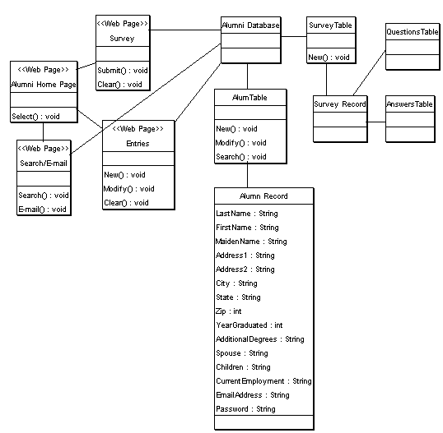
Figure 2 Architecture Design

Alumni Home Page
Name: Alumni Home page
Type: Web page
Description: This is the initial home page presented to the Alum upon connection with the Departmental Server. There are three buttons. One to fill out a survey, one to go to the entries page, and one to search/e-mail an Alum.
Attributes: None
Resources: None
Operations:
Name: Select()
Arguments: None
Returns: No return value
Pre-condition: Connected to site
Post-condition: On another page
Exceptions: None
Flow of Events:
- Alum is presented with the Alumni Home Page.
- Alum clicks a button
- Alum is connected to another page

Survey
Name: Survey Page
Type: Web page form
Description: When the Alum clicks the survey button he/she will be presented with a form. The form will have a combination of list boxes and blank fields to be completed. Some fields will be marked as required. When the form is completed the Alum can submit the form or clear the form. If the form is cleared the Alum can then enter information. If the form is submitted the information is saved on the Departmental Server in the Alumni Database.
Attributes: Text
Resources: None
Operations:
Name: Submit()
Arguments: None
Returns: Text file
Pre-condition: Connected to site
Post-condition: Form saved and faculty member e-mailed
Exceptions: None
Flow of Events:
- Alum is presented with form
- Alum fills in boxes and selects from list boxes
- Alum clicks submit
- Departmental server save data in a text file
- Departmental server sends an e-mail to designated faculty member
Name: Clear()
Arguments: None
Returns: No return value
Pre-condition: Connected to site
Post-condition: Form is cleared
Exceptions: None
Flow of Events:
- Alum is presented with form
- Alum fills in boxes and selects from list boxes
- Alum clicks clear
- Alum is presented with empty form

Entries
Name: Entries
Type: Web page
Description: This page has two links, one to add a new entry and on to update the Alum’s entry.
On the Add New Entry page the Alum is presented with a form to be completed. Once the Alum has completed the form the Alum can then either submit or clear the form. When the form is submitted the Departmental Server will check to ensure that the required fields are not blank. If the required fields are blank the Departmental Server will return a message stating a required field is blank. The all required fields are not blank the Departmental Server will create a new record in the Alum Table in the Alumni Database.
On the Update Information page the Alum will be presented with a drop down box list of years of graduation. The Alum chooses one of those years and clicks submit. The Departmental Server will return a list of all Alums from that year. The Alum will check his/her name and click submit. The Departmental Server will present a form requesting the Alum’s password. The Departmental Server will check the password against the password stored in the Alum’s record in the Alumni Database. If the passwords match the Departmental Server will return all of the data in that Alum’s record in a form with a message to update whatever information they wish and click submit or click cancel to make no changes. If the passwords do not match, the Departmental Server will return a message to contact the faculty member in charge of the Alumni Database to receive their password.
Attributes: None
Resources: None
Operations: New
Name: Submit()
Arguments: None
Returns: None
Pre-condition: Connected to site
Post-condition: New entry in Alumni database created
Exceptions: None
Flow of Events:
- Alum is on the Add Entry form
- Alum completes the empty boxes and chooses from list boxes.
- Alum clicks submit.
- Departmental server add the new entry to the Alumni Database
- Alum is returned to the Alum Home Page
Name: Clear()
Arguments: None
Returns: None
Pre-condition: Connected to site
Post-condition: Form is cleared
Exceptions: None
Flow of Events:
- Alum is presented with form
- Alum fills in boxes and selects from list boxes
- Alum clicks clear
- Alum is presented with empty form

Operations: Modify entry
Name: Submit()
Arguments: None
Returns: None
Pre-condition: Connected to site
Post-condition: Year selected is sent to the Departmental server
Exceptions: None
Flow of Events:
- The Alum is on the Update Entry Page
- The Alum is presented with a form that has a list box of years of graduation.
- The Alum chooses a year.
- The Alum clicks submit.
- The Departmental server returns a list of all graduates in the Alumni Database that graduated that year.
Name: Cancel()
Arguments: None
Returns: None
Pre-condition: Connected to site
Post-condition: Form is cleared and Alum is returned to the Alumni Home Page
Exceptions: None
Flow of Events:
- The Alum is on the Update Entry Page form
- The Alum fills in the fields he/she want to change
- The Alum clicks cancel
- The form is cleared and the Alum is returned to the Alumni Home Page

Search/E-mail an Alum
Name: Search/E-mail an Alum
Type: Web page
Description: The Alum is on the search/e-mail page. The Alum is presented with a list box of graduation date. The Alum chooses a date and clicks submit. The Departmental server queries the Alumni Database for all Alums that graduated that year. The Departmental server presents the Alum with a list of graduates. If the Alum that the requesting Alum is searching for is listed, the Alum will check the box next to his/her name and click submit. The Departmental server will retrieve the non-sensitive information about the requested Alum and present it to the Alum. The Alum can then either search for another Alum, e-mail that Alum if that Alum will accept e-mail, or return to the Alumni Home Page. If the Alum chooses to e-mail the Alum, the Department server will present the Alum with a box for the e-mail. The Alum then fills in the message to send and click send. The Departmental server will e-mail the message to the Alum with the sending Alum’s name and return the Alum to the search/e-mail page.
Operations:
Name: Submit()
Arguments: None
Returns: None
Pre-condition: Connected to site
Post-condition: Year/name is sent to the Departmental server
Exceptions: None
Flow of Events:
- The Alum is on the search/e-mail page.
- The Alum chooses a year/name from the list box
- The Alum clicks submit.
- The Departmental server queries the Alumni Database for the information
- If the information is present, the Departmental server will present it to the Alum.
Name: Cancel()
Arguments: None
Returns: None
Pre-condition: Connected to site
Post-condition: Form is cleared and Alum is returned to the Alumni Home Page
Exceptions: None
Flow of Events:
- The Alum is on the search/e-mail page
- The Alum clicks cancel
- The Departmental server returns the Alum to the Alumni Home Page
Name: Send()
Arguments: None
Returns: None
Pre-condition: Connected to site
Post-condition: The message is e-mailed to the requested Alum and the requesting
Alum is returned to the Alumni Home Page
Exceptions: None
Flow of Events:
- The Alum is on the e-mail page.
- The Alum types his/her message in the message box.
- The Alum clicks send.
- The Departmental server sends the message to the requested Alum and returns the requesting Alum to the search/e-mail page.

Alumni Database
Name: Alumni Database
Type: Database
Descriptions: The Alumni Database will reside on the Departmental server. The Alumni Database will be created and maintained in Access.
Attributes: Last Name: String
First Name: String
Maiden Name: String
Address: String
City: String
State: String
Zip: int
Year Graduated: int
Additional Degrees: String
Spouse: String
Children: String
Current Employment: String
E-mail Address: String
Receive e-mails: boolean
Password: String
Operations:
Name: New()
Arguments: None
Returns: None
Pre-condition: None
Post-condition: A new record is added to the Alumni Database Table
Exceptions: None
Flow of Events:
- The Alum is on the add an entry form page.
- The Alum fields in the fields
- The Alum clicks submit
- The Departmental server adds the new information as a table in the Alumni Database
Name: Replace()
Arguments: None
Returns: None
Pre-condition: The requested Alum is in the Alumni Database
Post-condition: The requested table is replaced with the new table
Exceptions: None
Flow of Events:
- The Alum is on the update entry page
- The Alum changes the field he/she wants changed
- The Alum clicks submit
- The Departmental server overwrites the existing table with the new table
Name: Search()
Arguments: None
Returns: Record
Pre-condition: None
Post-condition: The Alumni Database has been searched
Exceptions: None
Flow of Events:
- The Departmental server searches the Alumni Database for a particular record
- If the record is found the Departmental Server presents the record to the Alum

4.0. Data structure design
The data is stored in a relational database using Access. The relations are described by the database administrator for the CIS. The fields for transmitting to and from the database are given in the following table.

4.1. Data field types and sizes.
Attribute Name | Attribute Type | Attribute Size
LastName*# | String | 30
FirstName*# | String | 30
MaidenName*# | String | 30
Address1*# | String | 50
Address2# | String | 50
City*# | String | 30
State*# | String | 2
Zip*# | Int | 6
Year*# | Int | 4
AdditionalDegrees# | String | 50
Spouse# | String | 30
Children# | String | 50
CurrentEmployment# | String | 50
EmailAddress# | String | 20
ReceiveEmails#^ | Boolean | 1
Password*# | String | 10
EntireRecordVisible*^ | Boolean | 1

Fields marked with an ‘*’ are required fields. Fields marked with a ‘#’ can be visible or not visible and is determined by the Alum. Fields marked with a ‘^’ are never visible to anyone other than the Alum.

5.0. Use case realizations
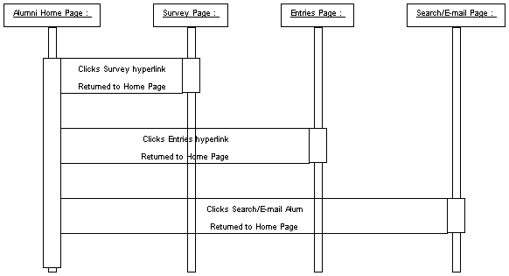
Figure 3 System Sequence Diagram

Use Case: Survey
See also Detail Survey in Software Requirement Specifications 3.2.

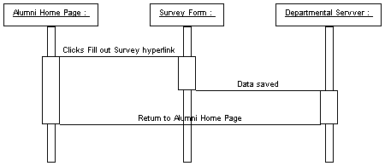
Figure 4 Survey Sequence Diagram

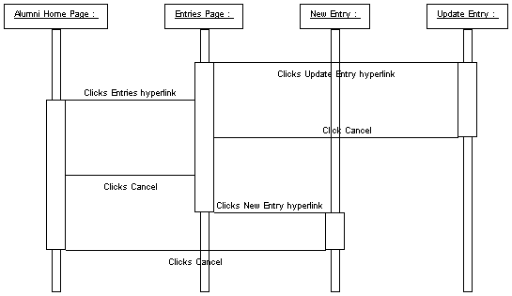
Figure 5 Entries Sequence Diagram

Use Case: Add Entry
See also Detail Add Entry in Software Requirement Specifications 3.2.
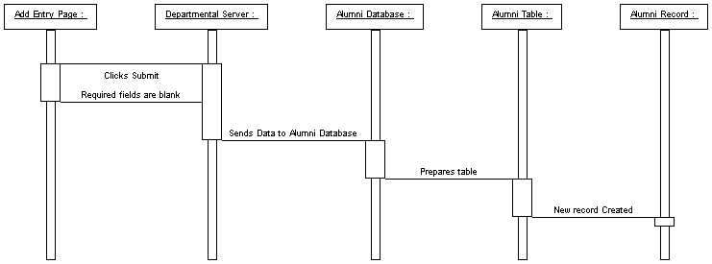
Figure 6 Add Entry Sequence Diagram

Use Case: Update Entry
See also Detail Update Entry in Software Requirement Specifications 3.2.

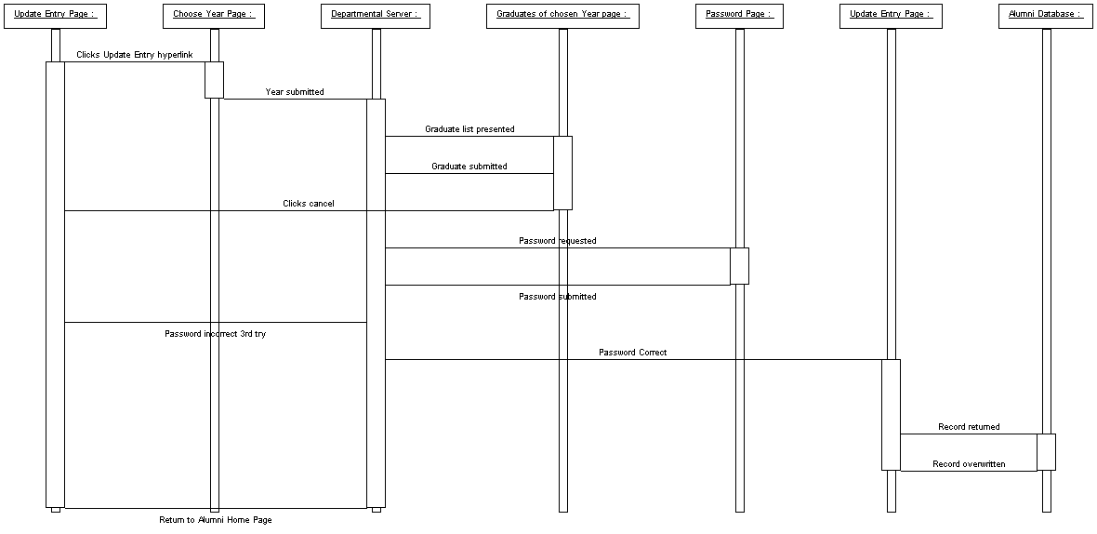
Figure 7 Update Entry Sequence Diagram

Use Case: Search/E-mail Alum
See also Detail Search/E-mail Alum in Software Requirement Specifications 3.2.

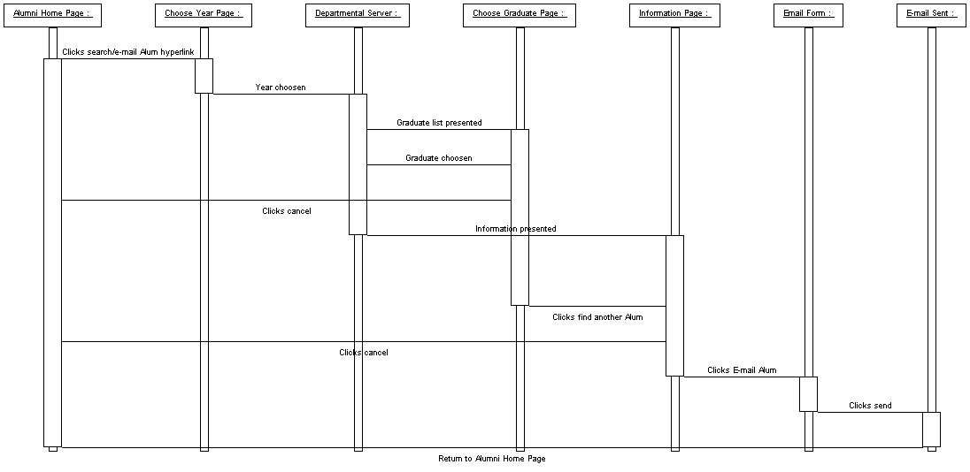
Figure 8 Search/E-mail Sequence Diagram

6.0. Interface design
The interface will use the same color and design scheme used on the other Jacksonville University Web pages to create a continuous effect. The exact pages will be placed here in a future version.
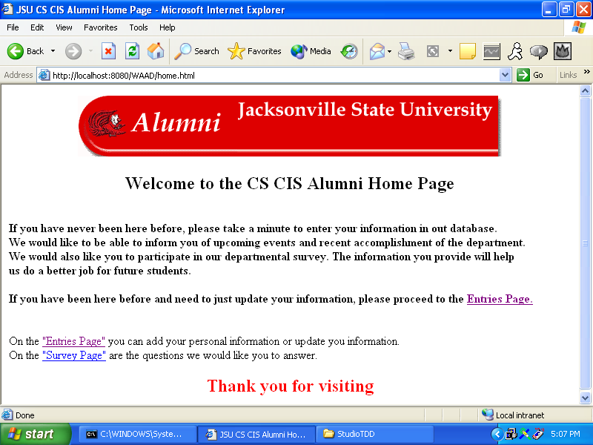
Figure 9 Home page
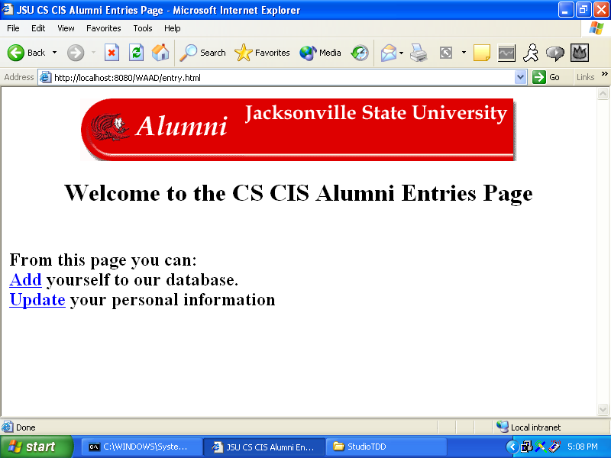
Figure 10 Entries page
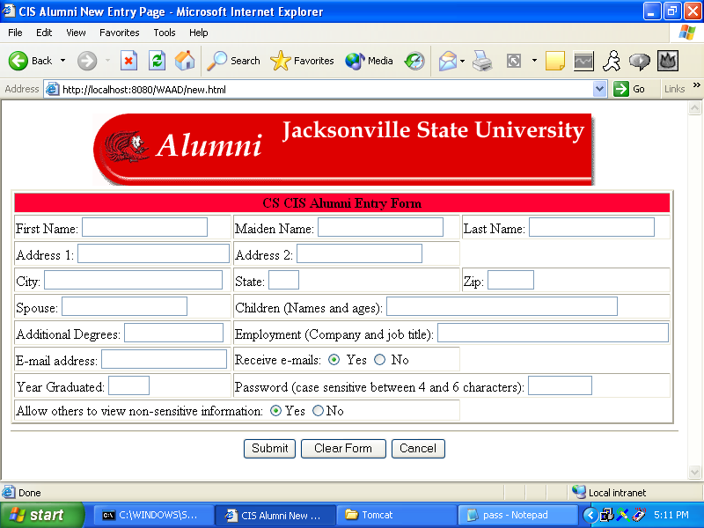
Figure 11 New Alum form page
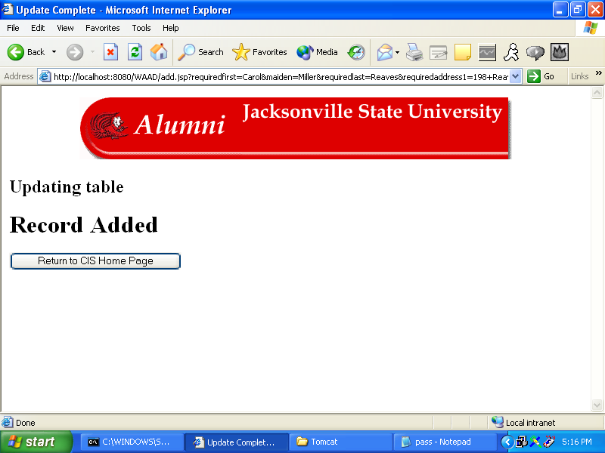
Figure 12 Recorded added page
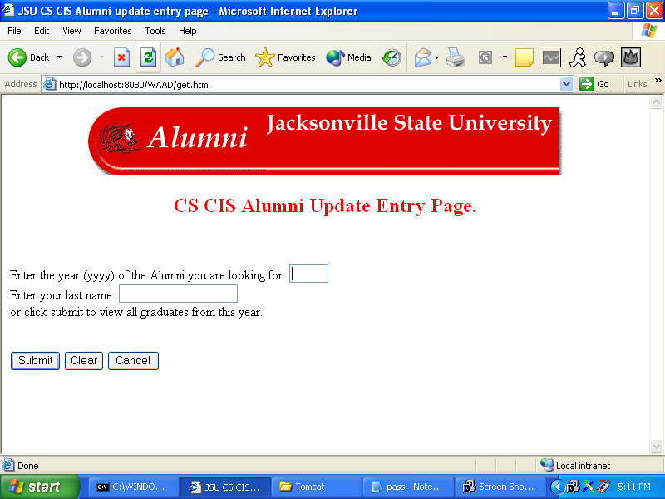
Figure 13 Get year page
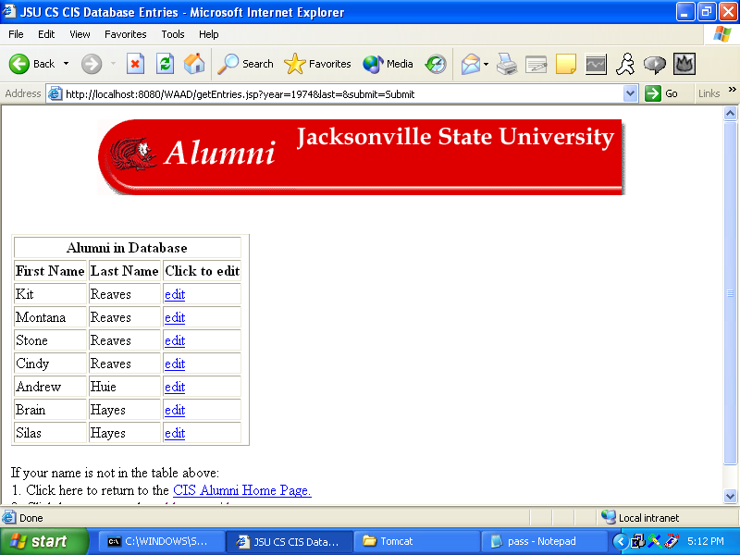
Figure 14 Get Alum page
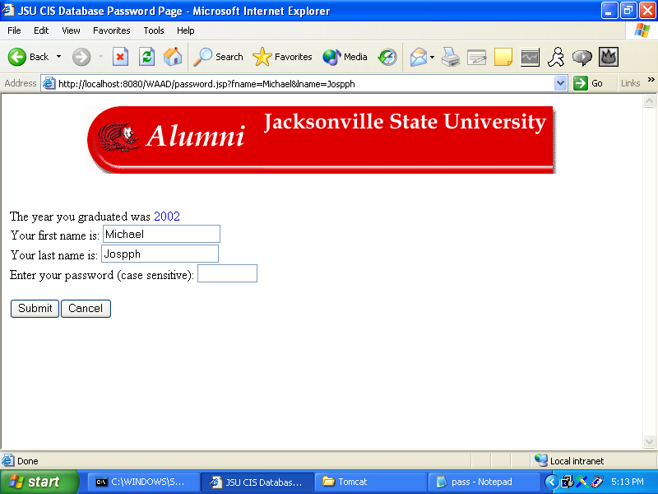
Figure 15 Get password page
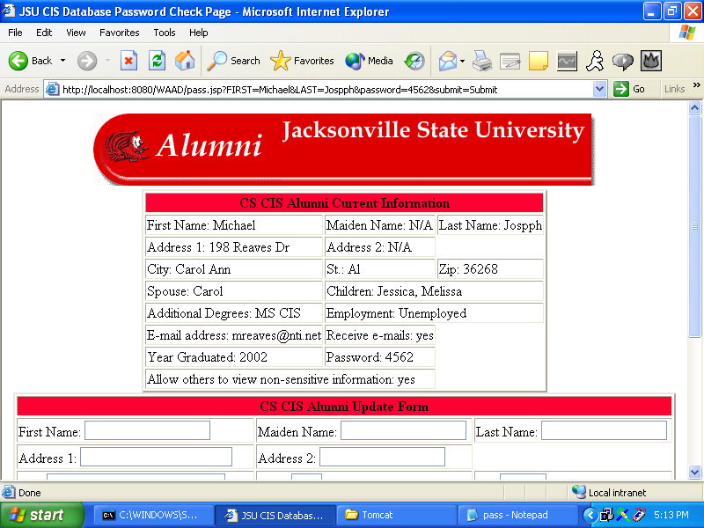
Figure 16 Data retrieved page
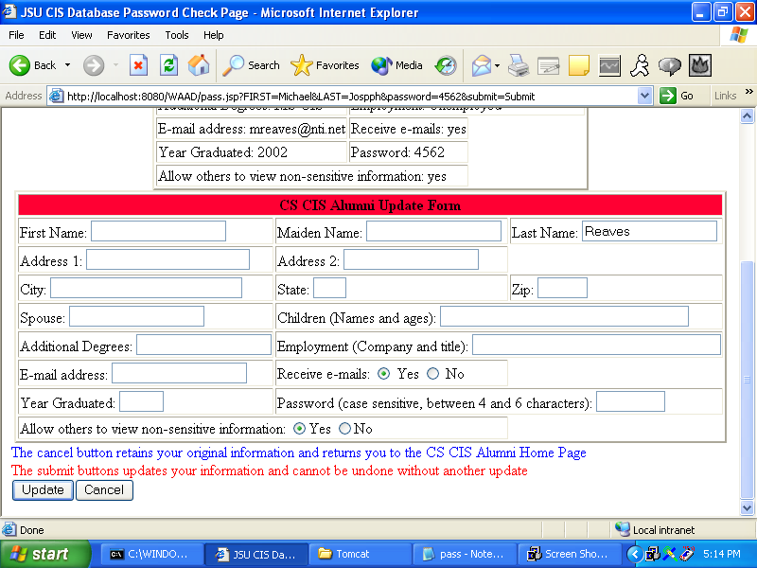
Figure 17 Data to update page
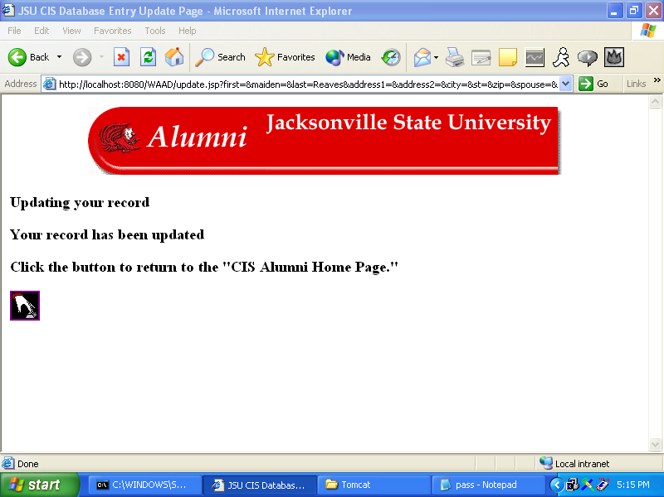
Figure 18 Record updated page
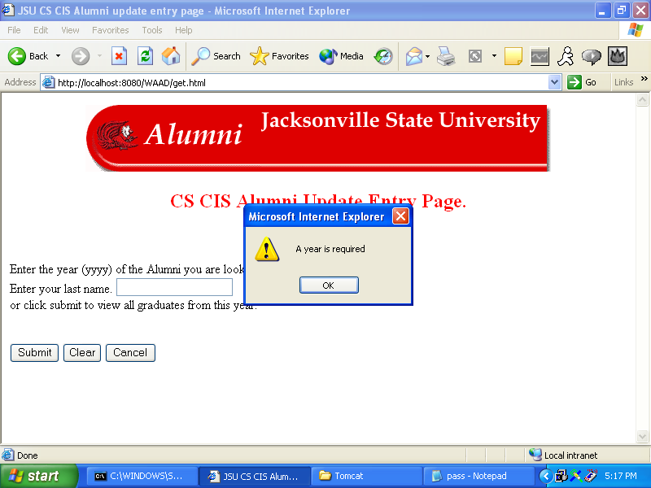
Figure 19 No year alert
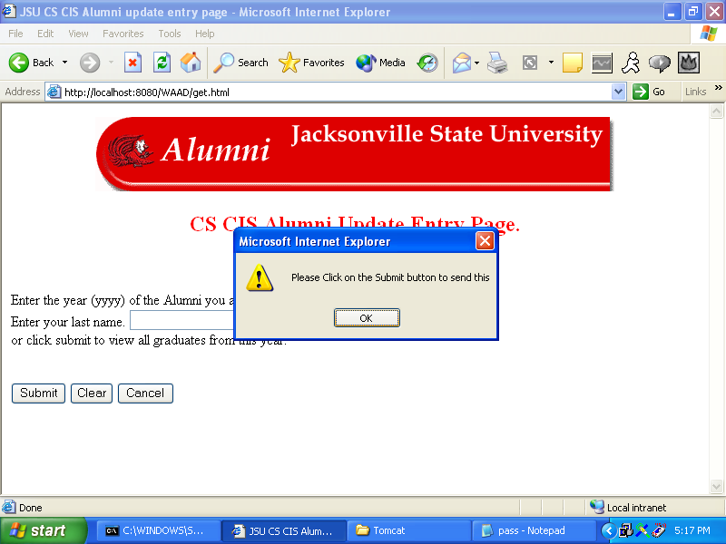
Figure 20 Return used instead of Submit
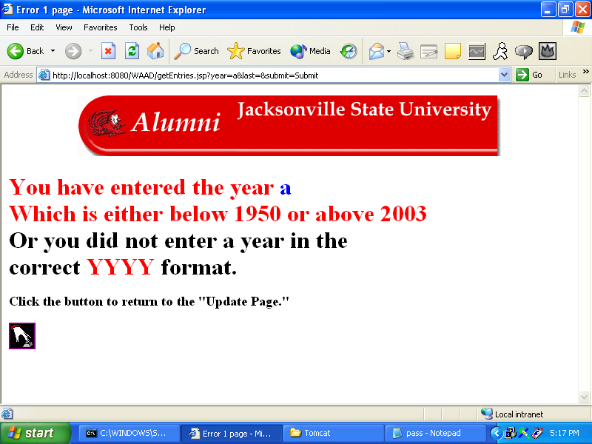
Figure 21 Incorrect year page
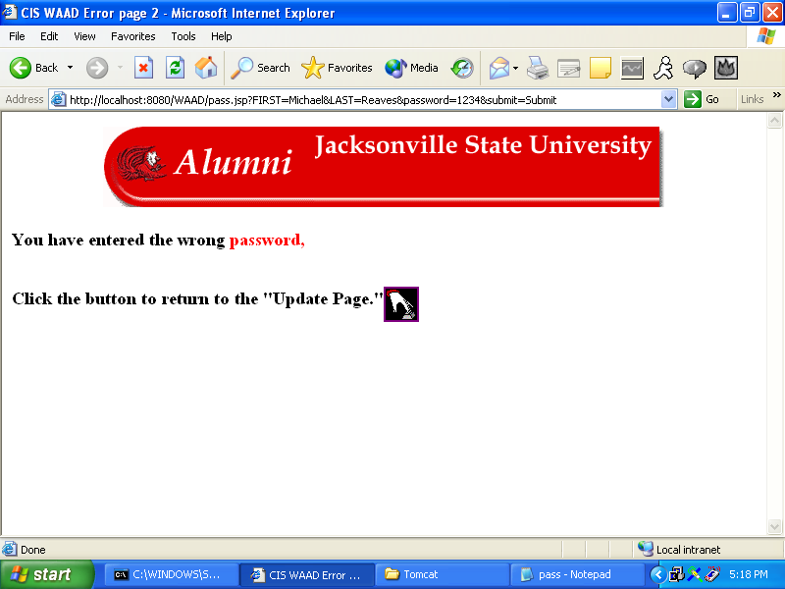
Figure 22 Incorrect password page
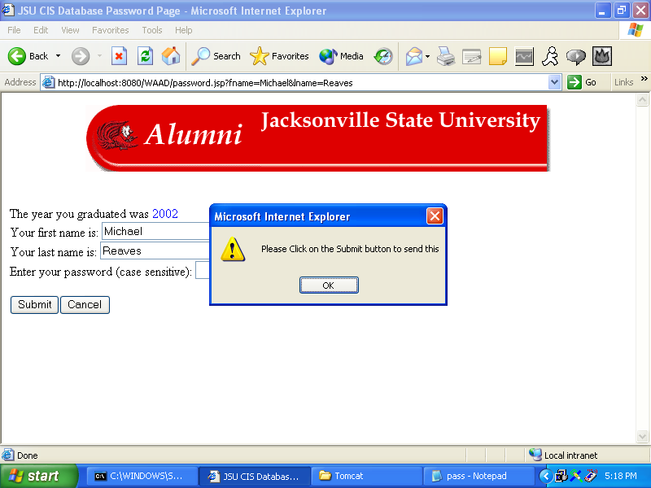

Figure 23 Return used instead of Submit

7.0. Help system design
At this time there is no help system needed or planned.

8.0. Index

Administrator, 11
Attributes, 5, 6, 7, 9
Audience, 1
Borland Database Engine, 1
Configuration Item, 1
Customer, 5, 6
Database, 1, 2, 4, 6, 7, 8, 9, 10, 11
Function, 2
Institute of Electrical & Electronic Engineers, 1, 2
Quality Assurance, 2
Resources, 5, 6, 7
Server, 1, 4, 5, 6, 7, 8, 9, 10
Software Configuration Management Plan, 2
Software Design Document, 1, 2
Software Engineering Institute, 2
Software Project Management Plan, 2
Software Quality Assurance Plan, 2
Software Requirement Document, 2, 3
System, 3, 4, 5, 12, 23
Use Case, 12

